|  |  |  |  |  |  |
| --- | --- | --- | --- | --- | --- |
| Phonics | | English | | Maths | |
| Children will recap the sounds required in their Phonics Screening Check. | | The children will be working on their story writing skills using the text ‘Lost and Found’ by Oliver Jeffers. They will them move onto writing weather poems. | | We will be introducing children to multiplication, division and fractions. Children will be learning to count in 2s,5s and 10s. They will recognise and find half and quarters of an object, shape and quantity. | |
| Science | Geography | | RE | | Art |
| Our Topic is ‘Seasons and Weather’. Children will learn about the four seasons and know that tools are used to gather data about the weather. Please see the knowledge organiser below. | Our topic is called ‘The Seven Continents’. Children will learn all about the seven continents and five oceans. They will understand the Equator is an imaginary line around the middle of the Earth. Please see the knowledge organiser below. | | Our topic is 'What do we learn from stories?’ We will be exploring how stories can help us to learn a variety of things about our world, our emotions, and deepen our understanding of our experiences. | | Our art topic is ‘Sculpture’, where the children will be exploring 3D art, moulding and casting. Please see the knowledge organiser below. |
| Music | PSHE | | PE | | Computing |
| We will continue to use the Charanga programme to teach music lessons. We will learn about songs to help us through the day, and continue to improvise music through these themed songs. | Children will learn about ‘Being My Best’, thinking about looking after their bodies through healthy eating, regular exercise, and being cautious of germs. | | The children will be learning how to run, jump and throw with good control and coordination. Children will also show good teamwork and sportsmanship when taking part in athletics. | | The children will be learning coding skills by controlling our Bee Bot robots. They will learn how to program them, clear code and solve problems relating to position and direction. |

Science Knowledge Organiser

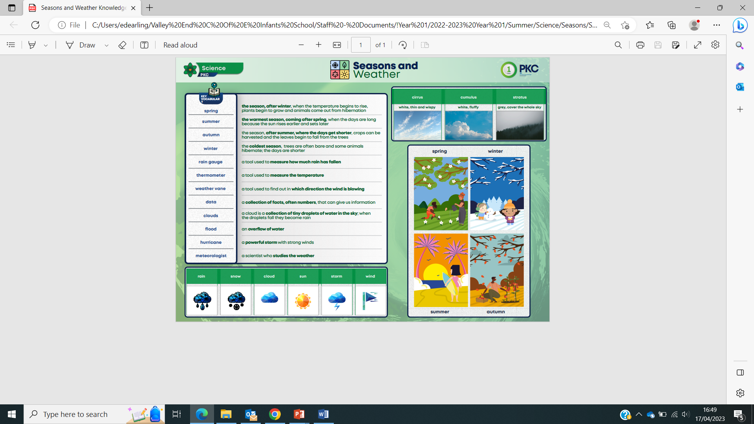

Geography Knowledge Organiser

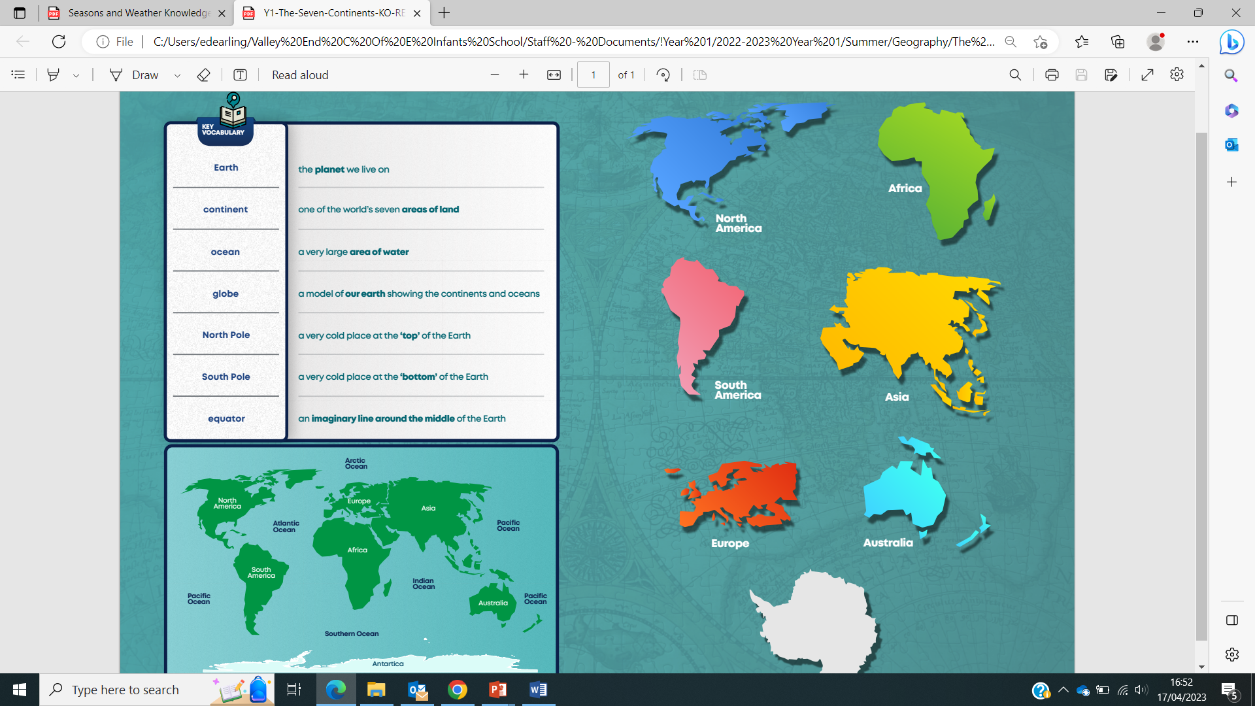Art Knowledge Organiser

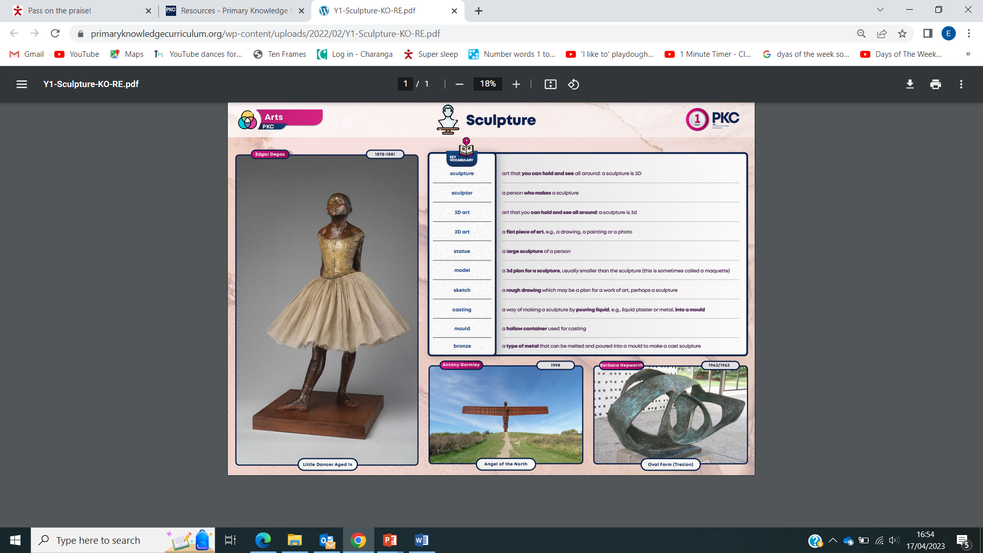

RE Knowledge Organiser

