Year 1 Home Learning Matrix
Please see the suggested activities below for you to complete with your child at your leisure. Your child will receive a home learning wallet which will contain resources that they will need for the half term. Children are welcome to bring in completed homework at any time to share with the class.
Science  Make a collage out of natural objects. How many different items can you use? Can you describe the texture and how it feels?  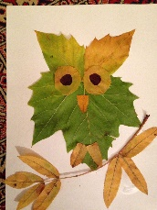 | Geography  Draw a map of your bedroom, house or garden. See how many parts of your map you can label.  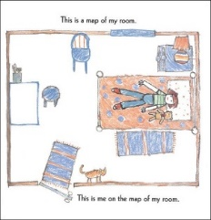
Maths  Use objects from around your home such as pasta, Lego or pens to represent numbers up to 10 (or 20 for a challenge). Can you write the numbers as well? If you want to bring in a photo to show us, please do.  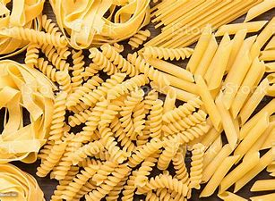 | Handwriting  Using the handwriting paper provided, practise writing your name carefully on the handwriting lines. Feel free to practise other letters on the paper also.
English  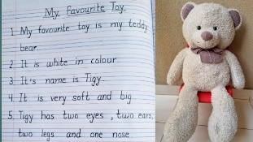  Draw a picture of your favourite toy and write a sentence to explain why it is your favourite. | PSHE  Show your family in any way you choose. This could be through a drawing, collage, model, playdough, etc.  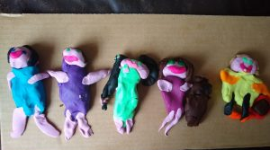  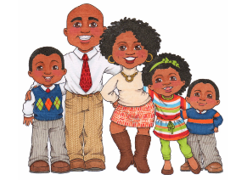
Music  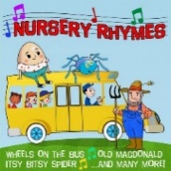  See if you can find a new nursery rhyme to learn. You could also make up some actions to a song you already know. | RE  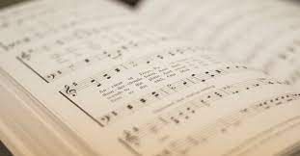  Listen to or learn a hymn/song of worship and think about the words and the meaning.

