|  |  |  |  |  |  |
| --- | --- | --- | --- | --- | --- |
| Phonics/Reading | | English | | Maths | |
| In phonics we will be re-capping the phase 5 sounds and spelling the Year 2 common exception words.  Guided reading sessions will happen twice per week.  Those on Little Wandle books will still have two reads a week focusing on decoding, intonation and comprehension. Those children reading colour band books will be working on reading fluently and then talking in depth about the book. | | English this half-term will be focused on two key texts: The Enormous Turnip and a Florance Nightingale passage.  For each of these texts we will be learning the text together in oral form, acting the story out and then learning how to adapt the story or passage. After internalising key features of the chosen texts, we will be doing pieces of independent writing for different contexts. | | This half-term we want to secure the children’s knowledge of number. For that reason, we will be focusing on place value for most of this period. We will be securing the knowledge of what makes up a number – how many tens it has and how many ones it has. We will be using a step-by-step process using concrete resources (things you can touch) pictorial (pictures) and then applying this to abstract representations e.g numerals and number sentences.  We will also be exploring addition nearer the end of this half term. | |
| Science | RE | | Geography/History | | Art and DT |
| In science this half-term we will be exploring the human body. We will be studying the skeleton, muscles and internal organs such as the heart. We will also be talking about influential scientists and how they have impacted modern day medicine. | This half-term we will be looking at Christianity. We will be discussing why the Bible is important to people as well as diving into some of the stories. One Biblical story we will be particularly focused on is the story of Joseph. We will consider how Joseph felt throughout his story. | | Each half-term we will alternate between a Geography unit and a History unit.  This half-term we will be focused on History. We will be looking at people that have ‘powerful voices’ and have made a difference to the world we live in today. | | Each half-term we will alternate between an Art unit and a DT unit.  In art this half-term we will be looking at self-portraits. We will be using mirrors to look at intricate details on our faces. We will use a range of materials to create these self-portraits. During these lessons we will also explore colour mixing. |
| Music | PSHE | | PE | | Computing |
| This term we will be looking at the pulse, rhythm and pitch of different pieces of music. We will also be practising our songs for the Chobham Prom using these skills. | This half-term we are going to be talking about what it means to be a good friend. We will be learning how to identify our own and other’s feelings. We will delve into bullying and discuss what to do if we see someone being bullied. We will also partake in activities that we find calming. | | This term we are looking at invasion games – such as football, hockey and netball. We will be learning the skills that are needed for these games such as throwing, passing and dribbling.  We will also be learning how to work as a team to achieve a common goal. | | This half-term we are going to be looking at online safety. This includes who can see online information and how to protect ourselves.  Alongside this we will also be looking at how to use Google and QR codes. This will be using the iPad as part of our English lessons. |

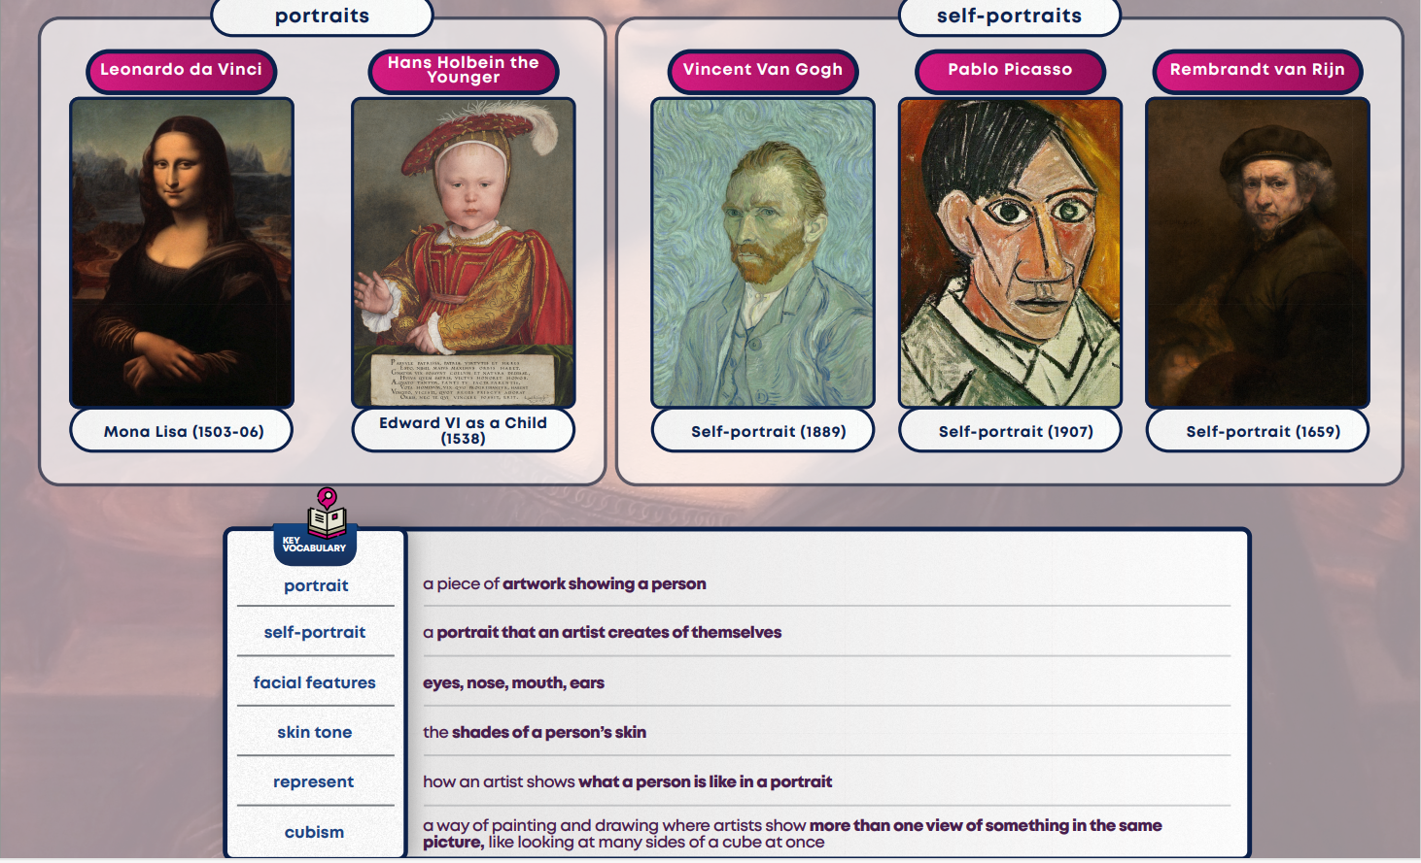

Art – Shape Colour and texture

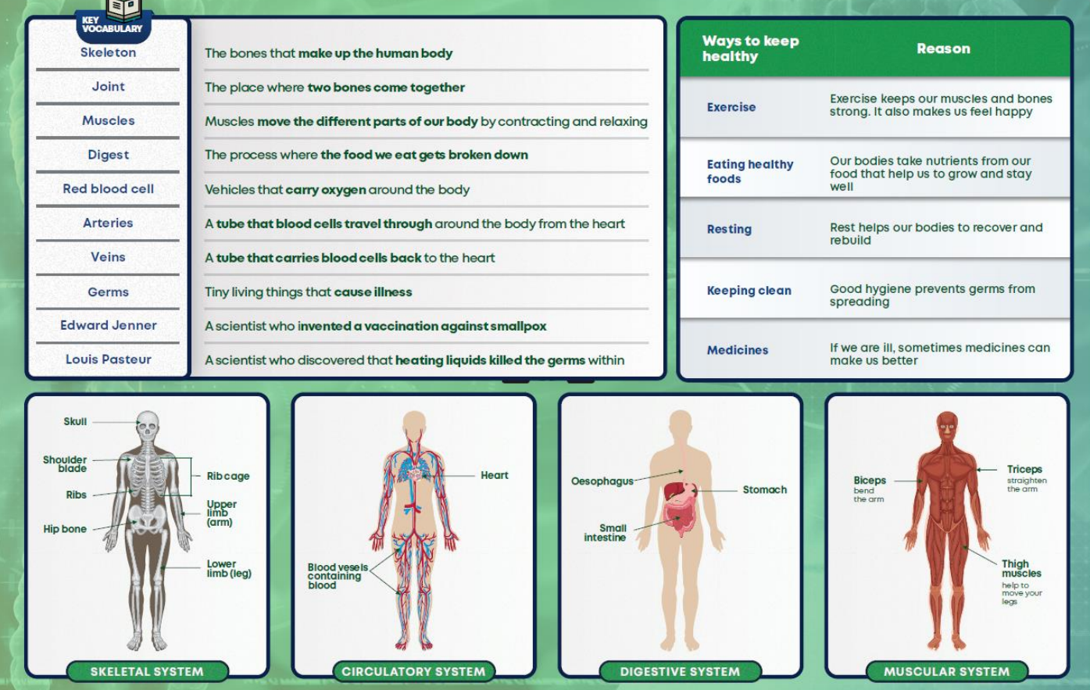

Science – The Human Body

History – Powerful Voices

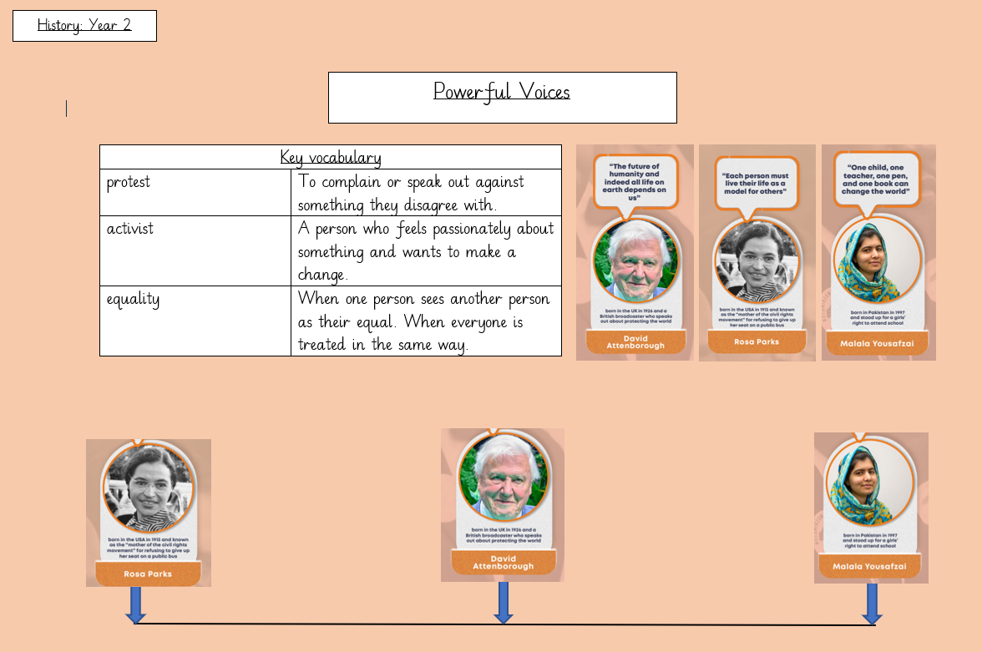

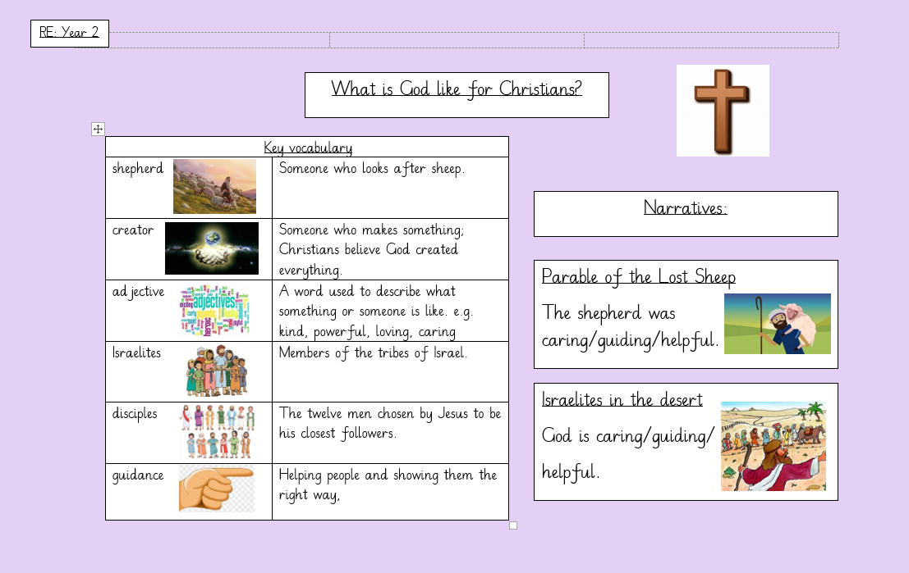

RE – What is God Like?

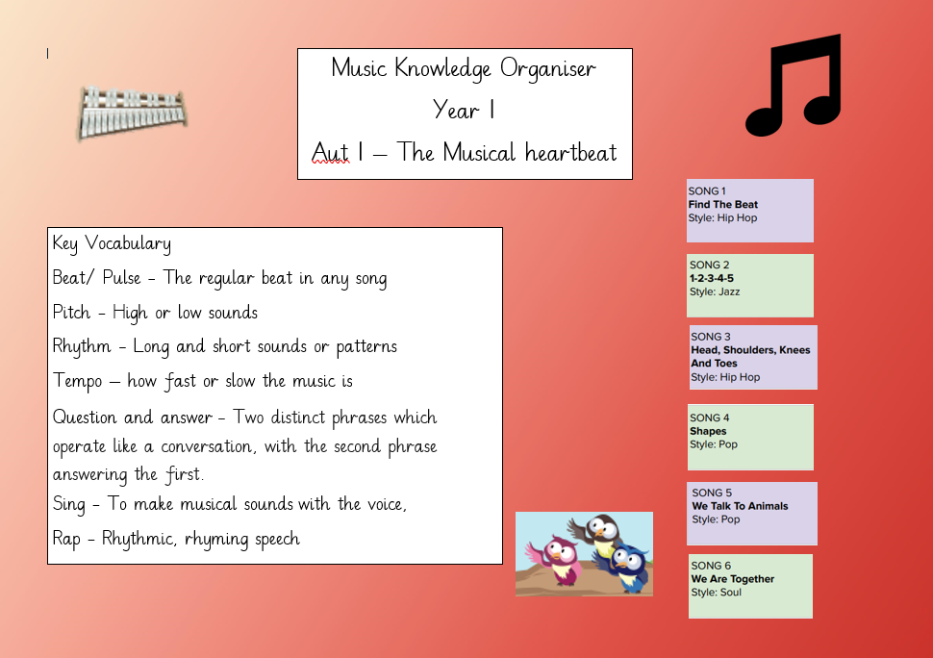

Music – The Musical Heartbeat