Year 2 Learning Objectives

Spring Term w/b Monday 2nd June

This week in school we will be learning…

English – to look at different features of a recount.

Maths – to be able to tell the time to the minute and in 5 minute intervals.

Foundation learning

Computing – to explain that a sequence of commands has a start

Music – End of year show practise.

PSHE – to demonstrate simple ways of giving positive feedback to others.

PE – To explore different running and jumping techniques.

Geography – to identify the countries within Northern Europe.

Spellings –

RULE:. Why do some longer words have the spelling ti for sh?

\*Next page for practise words and dictation\*

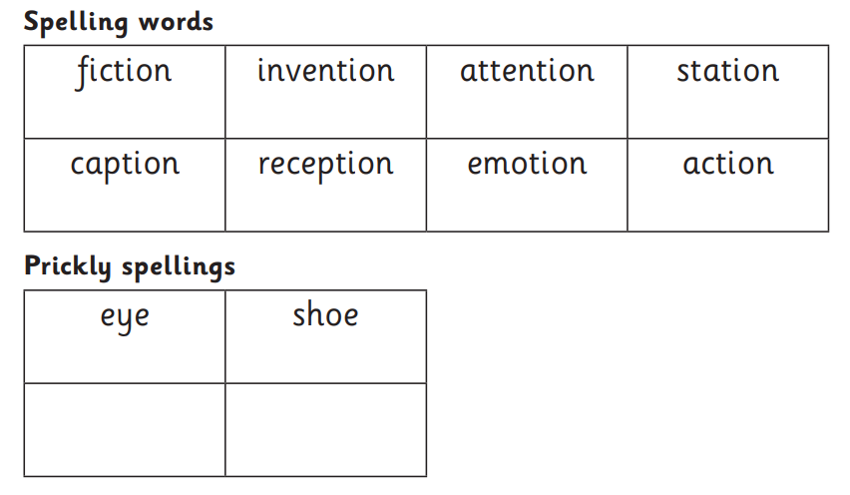

Dictation:

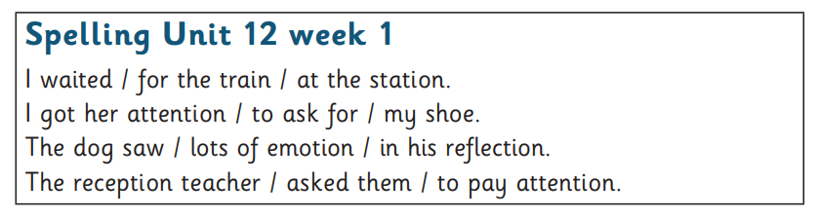

Additional homophone practise:

