Year 2 Learning Objectives

Spring Term w/b Monday 10th February

This week in school we will be learning…

English – To write a non-chronological report about a topic of our choice.

Maths – To times and divide by 2, 5 and 10.

Foundation learning

Science – To explore the difference between solids, liquids and gases.

Computing – To create and debug a program.

## PSHE – To be able to identify safe and unsafe secrets,

PE – To build on their performance and teambuilding skills.

Music – To continue to practise playing B/A/G on the recorder.

RE – To know what is important to Muslim families.

Spellings – To put what we have learnt over this half term into practice.

*Next page for practise words and dictation*

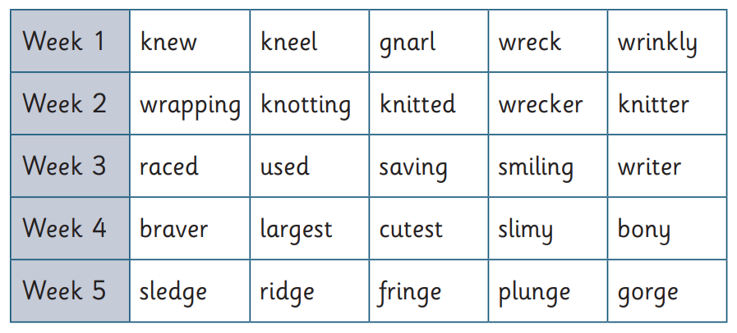

Dictation:

