Year 2 Learning Objectives

Spring Term w/b Monday 13th January

This week in school we will be learning…

English – To learn the features of a setting description (expanded noun phrases, prepositions).

Maths – To count money in pounds and pence. To make the same amount with different coins. Making a pound.

Foundation learning

Science – To know that inventors think carefully about materials and their properties focusing on George de Mestral and Velcro.

Computing – To explain what happens when we change the order of instructions using Beebots.

## PSHE – To be able identify situations in which they would feel safe or unsafe.

PE – Hockey agility and coordination. To explore different shapes, we can make during dance.

Music – Recapping pitch through a musical cartoon, bouncing with the B note and learning and playing notes A and B together on the recorder.

RE – To know why the Qur’an is special to Muslim families

Spellings –

RULE: Doubling the final letter to protect the short vowel sound when you add –ing, -er & -ed.

*Next page for practise words and dictation*

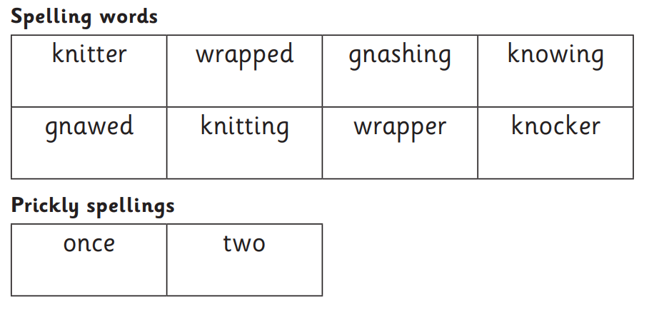

Dictation:

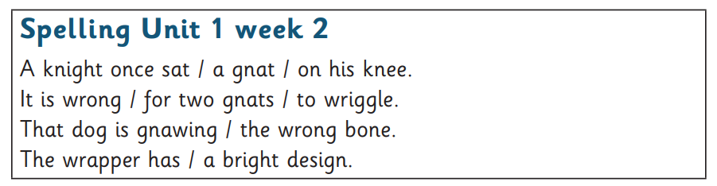

Additional homophone practise:

