Year 2 Learning Objectives

Spring Term w/b Monday 17th March

This week in school we will be learning…

English – to learn about the features of persuasive writing.

Maths – to measure in ml and litres.

Foundation learning

Science – to know that the moon orbits the Earth and to look at the moons position.

Computing – to create a pictogram.

PSHE – to be able to identify special people in the school and community who can help to keep them safe.

PE – Netball – to understand the importance of warming up for exercise. Gymnastics – to remember and repeat a range of actions with control and precision.

Music – Fox – Glockenspiels Badger - Recorders

RE – To know how Jesus rescued Zacchaeus

Spellings –

RULE: Why do some words have the spelling ey for the sound /ee/?

\*Next page for practise words and dictation\*

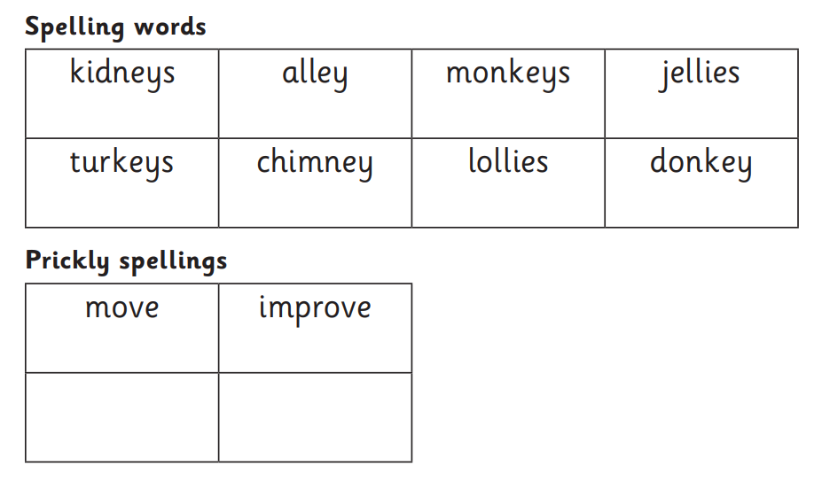

Dictation:

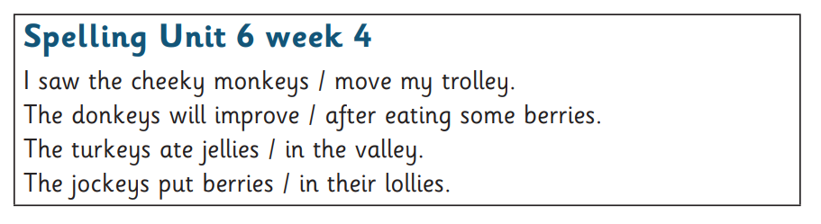

Additional homophone practise:

