Year 2 Learning Objectives

Spring Term w/b Monday 24th March

This week in school we will be learning…

English – Planning our own persuasive advert

Maths – To be able to measure temperature

Foundation learning

Science – to know that groups of stars are called constellations.

Computing – To select objects by attribute and make comparisons

PSHE – to identify what they like about the school environment

PE – Netball – to copy actions and ideas to help become successful. Gymnastics – to perform a range of actions with control and coordination.

Music – Badgers – recorder. Foxes - glockenspiels

RE – To know the ‘rescue’ of the Easter Story

Spellings –

RULE: Why do some words end -le, -al, -il, or -el?

\*Next page for practise words and dictation\*

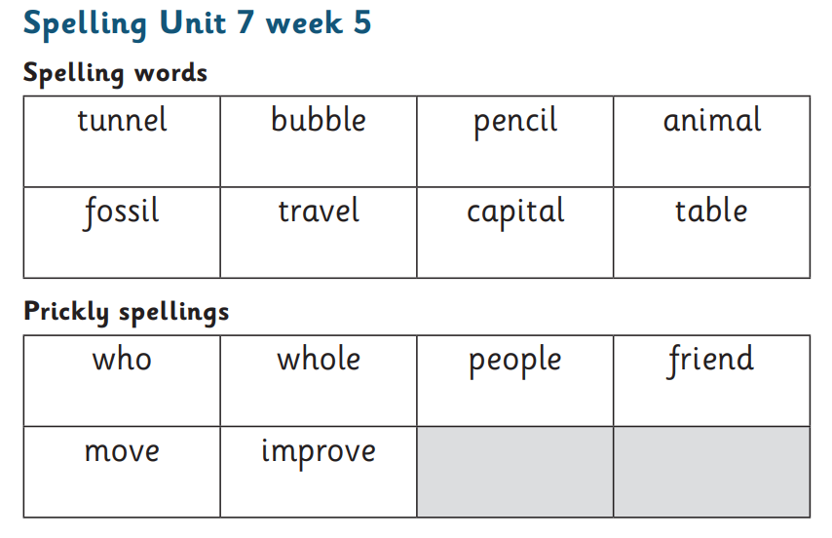

Dictation:

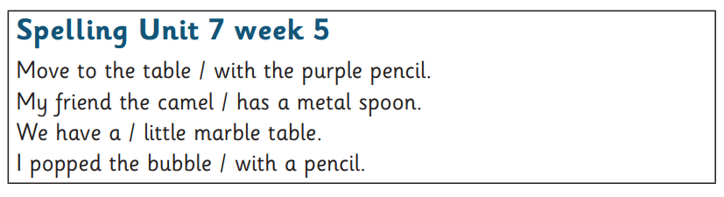

Additional homophone practise:

