Year 2 Learning Objectives

Spring Term w/b Monday 10th February

This week in school we will be learning…

English – To practise writing facts and opinions and the difference between these.

Maths – Grouping objects, sharing objects, 2 timetables, dividing by 2.

Foundation learning

Science – To understand that water can be a solid and can also be a liquid.

Computing – To design an algorithm

## PSHE – To be able to recognise that some touches are not fun and can hurt or be upsetting.

PE – To pass the ball with accuracy and to combine dance movements learnt over the unit.

Music – To recap dynamics through musical cartoon. To learn and play a 4 bar melody on the recorder.

RE – To know how Muslims show that something is important

Spellings – Why do some words end dge or ge? Why can /j/ be spelled j or g in different words?

RULE: We use ge if there is a diagraph before the /j/ sound.

*Next page for practise words and dictation*

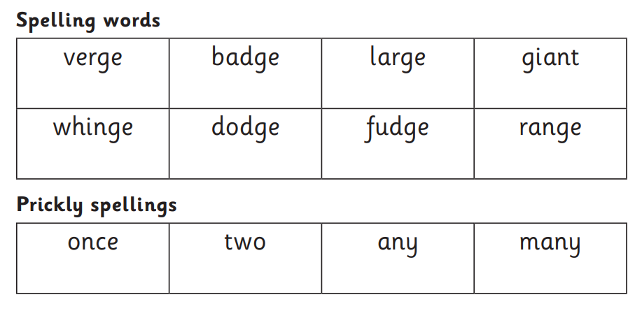

Dictation:

