Year 2 Learning Objectives

Spring Term w/b Monday 3rd March

This week in school we will be learning…

English – To look at 5-part stories (beginning, build-up, problem, solution, end).

Maths –

Foundation learning

Science – to know and order the eight planets of the solar system.

Computing – To recognise that we can count and compare objects using tally charts.

PSHE – to describe and record strategies for getting on with others in the classroom.

PE –

Music –

RE –

Spellings –

RULE:

\*Next page for practise words and dictation\*

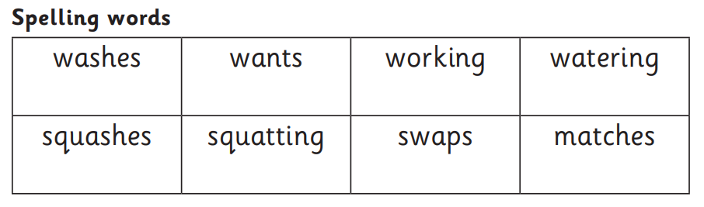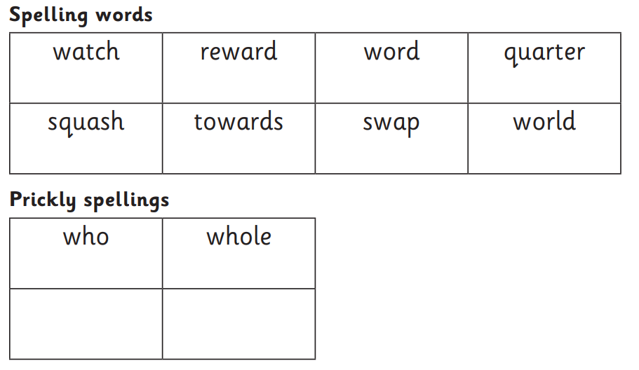

Dictation:

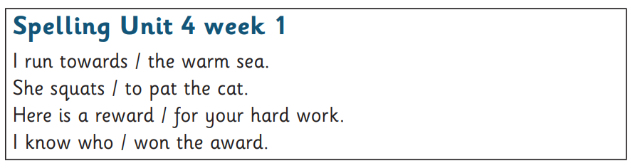

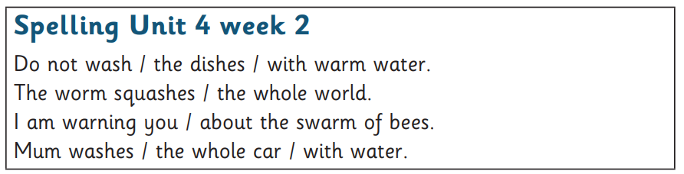

Additional homophone practise:

