|  |  |
| --- | --- |
| Key vocabulary | |
| Journey | When we travel from one place to another. |
| Transport | When we travel using a vehicle. |
| Road safety | Rules to keep us safe when we travel. |

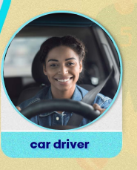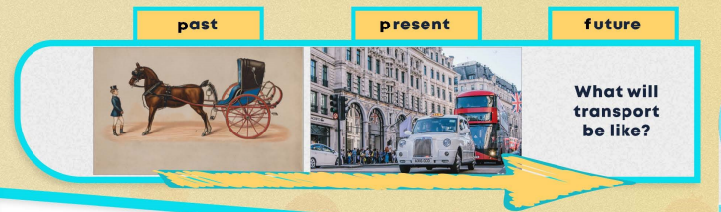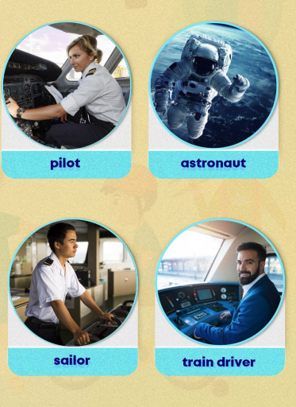

Transport

Topic: Reception