|  |  |  |  |  |  |
| --- | --- | --- | --- | --- | --- |
| Phonics/Reading | | English | | Maths | |
| We will continue with reading fluency books three times a week with written comprehension twice a week. Those on Little Wandle books will still have three reads a week focusing on decoding, intonation (prosody) and comprehension.  In spelling we will be learning different rules for adding suffixes to root words. | | Throughout this half term we will be writing two different texts. The first one will be focused around a recount of our school trip and the second will be writing an information booklet. Throughout this term we will be focusing on the key skills required for Year 2 such as subordinating conjunctions and making sure everything is in a consistent tense. | | We will continue to learn how to tell the time. Children will be able to tell the time to O’clock, half past, quarter past and quarter to as well as to 5 minutes.  We will then move onto Statistics, position and directions. | |
| Science | Geography/History | | Art and DT | |
| This term we are celebrating science with a science activity day where we will spend the whole day investigating and experimenting. | Each half-term we will alternate between a Geography unit and a History unit.  This half-term will be focused on Geography, specifically Northern Europe. We will be looking at the countries and how people and animals have adapted to survive the cold winters. | | DT day will take place in Summer two which will have a cooking focus. | |
| Music | PSHE | | PE | | Computing |
| This half term we will be practising the skills we have learnt this year through our end of year play! We will be learning to sing, dance and act. We will also be learning what it means to perform. Children will get a chance to either say a line, dance or sing. | This half-term we are going to be talking about how we grow and change with a focus on moving into year 3 and what happens at different stages of our life. | | This term we will be focused on athletics and tennis. | | This half-term we are going to be looking how to design and create our own quizzes using iPads. |

Science – plants

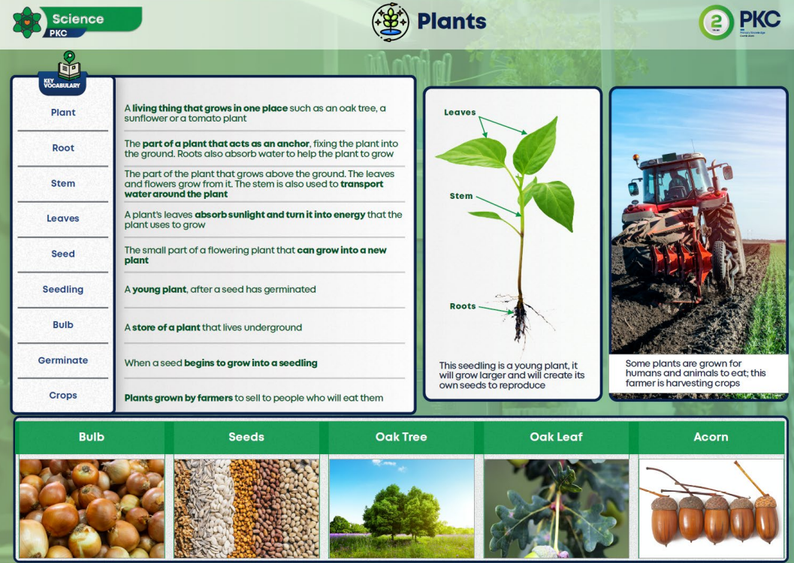

History – The Romans

